Establishing universal scaling laws for pressure fluctuations in high Reynolds number rough wall turbulent boundary layers

Version information
Updated: September 2019
Project contact: William J. Devenport
E-mail : wdevenpo@vt.edu

Sponsoring Agencies
- Office of Naval Research
875 North Randolph Street
Arlington, VA 22203-1995
Grant Numbers: N00014-15-1-2247, N00014-19-1-2109, N00014-18-1-245
Technical Monitors: Joseph Gorski and Thomas Fu
- National Science Foundation
Grant Numbers: CBET-1436088

Reference articles
Articles fully documenting the experiments and the resulting data contained here are available [hyperlink here] and listed below.
- J. B. Forest. The wall pressure spectrum of high Reynolds number rough-wall turbulent boundary layers. Master's thesis, Virginia Tech, 2012.
- T. W. Meyers. The rough wall high Reynolds number turbulent boundary layer surface pressure spectrum. Master's thesis, Virginia Tech, 2014.
- T. Meyers, J. B. Forest, and W. J. Devenport. The wall-pressure spectrum of high Reynolds-number turbulent boundary-layer flows over rough surfaces. Journal of Fluid Mechanics, 768:261-293. 2015.
- L. A. Joseph. Pressure Fluctuations in a high-Reynolds-number turbulent boundary layer over rough surfaces of different configurations. PhD thesis, Virginia Tech, 2017.

Introduction
Most flows of practical interest are turbulent in nature, typically occurring next to a rigid surface such as a submarine hull or aircraft wing. This boundary layer ow is of engineering importance because its pressure fluctuations are the source of unwanted structural vibrations and undesired acoustic noise. From a purely scientific perspective, it is useful to study the turbulent pressure fluctuations in order to learn more about the workings of the region of the flow closest to the surface.
It has been found that there are significantly greater pressure fluctuations over the more practical rough wall cases than theoretical smooth walls. Consequently the extent of vibrations and noise which occur in rough walls is larger than that experienced in smooth walls. The present data was collected with the goal of exploring the nature of the rough-wall turbulent boundary layer through wind tunnel experiments. The data include velocity and pressure fluctuations, and the boundary layer parameters derived from these.

Wind Tunnel and Major Instrumentation
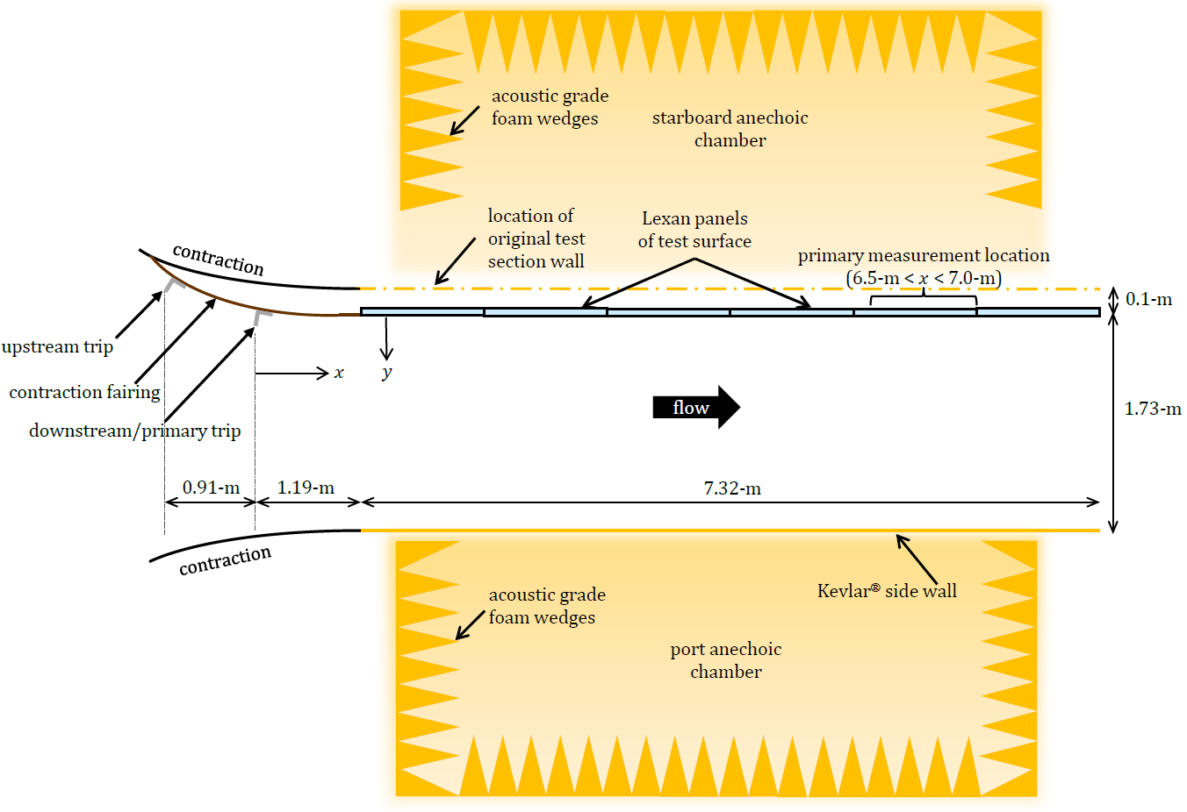
Experiments were carried out the in semi-anechoic test section of the Virginia Tech Stability Wind Tunnel, a closed-circuit low-speed facility with removable test sections [hyperlink to website]. This facility has close to uniform free stream flow and turbulence levels of 0.024% at 30-ms⁻¹ and 0.031% at 57- ms⁻¹ in the empty test section. The test section, with coordinate system, is presented in figure 1.
Figure 1 Semi-anechoic configuration of Virginia Tech's Stability Wind Tunnel
An Esterline NetScanner Model 98RK (range ±10-inWC, resolution ±0.003, accuracy = 0.05%) recorded the signal from twenty four pressure taps embedded in the adjacent perpendicular walls along the sides of the test surface. The pressure taps were located between $1.6≤x≤8.1$-m and between $0.25≤y≤0.3$-m away from the test surface. The free-stream static pressure, velocity, and stagnation pressure were derived from pressure taps embedded in the contraction, 2.51-m upstream of the test section leading edge. A thermocouple in the contraction measured the ambient temperature.
Turbulent velocity fluctuations were measured using two Auspex Corporation model AVOP-4-100 quadwire probes, arranged in tandem to take data simultaneously using Dantec 90C10 CTA modules. The CTA modules have flat frequency response up to 10-kHz, and samples data up to 50-kHz with an accuracy of 0.03%. Quadwire data were validated by Auspex AHWU-100 constant-temperature single hotwire probes and a flattened Pitot probe. Velocity measurements were made approximately 7.0-m downstream of the primary trip and typically in the middle of a four element array of roughness elements (except on the superposed roughness surfaces where data was taken at different locations relative to each type of roughness).
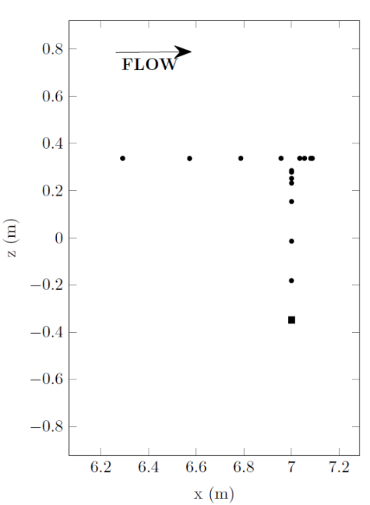
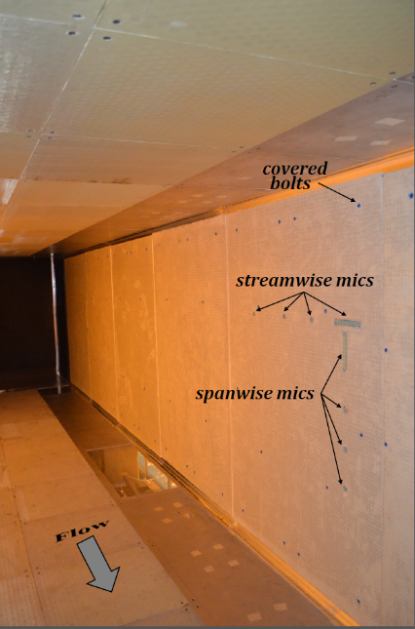
The pressure fluctuations were measured using seven Bruel & Kjaer 4138-A-015 $1/8$-in microphones. 0.5-mm pinhole caps were used to reduce the spatial averaging of the small-scale structures by reducing the microphone sensing area. A B&K Type 3050-A-060 LAN-XI and B&K type 3050-A-060 Pulse Analyser were used for microphone signal acquisition and conditioning, at a sampling rate of 65536-Hz for 32-s. The microphones were installed on the test surface, between $6.3≤x≤7.1$-m, using 3-D printed microphone holders at eight streamwise locations and seven spanwise ($z$) locations, as shown in figures 2. A Bruel & Kjaer 4182 probe microphone, with a 0.75-mm sensing area, was used as a reference microphone to isolate the facility's background acoustics. On surfaces with single roughness element types, microphone holders were designed to place the microphones as close as possible to the centre of a square array of four roughness elements. In the case of the multi-scale surfaces, microphone holders were designed to obtain unsteady pressure data at various element-relative locations.
Figure 3 (a) Diagram of microphone locations in both streamwise and spanwise directions and the reference microphone (▪) (b) Microphone mounts installed in test section with rough surface (cylindrical rough elements)

Rough Surfaces
In addition to a smooth wall, a total of five roughness fetches were fabricated and tested. Using the rough surfaces investigated by Meyers et al. (2015) (see figure 3) as baseline cases, five additional surfaces (see figure 4) were designed to create a diverse but logical set of roughness fetches. The specifications of all roughness fetches are given in table 1.
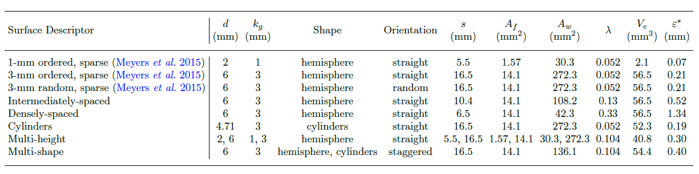
Table 1 Geometric specifications of rough surfaces under consideration in this work
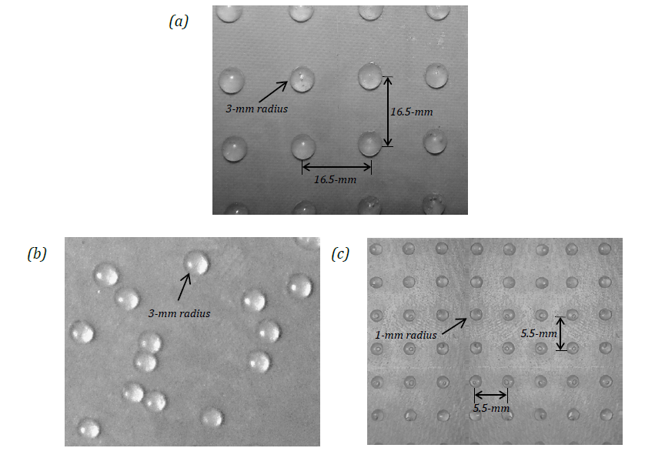
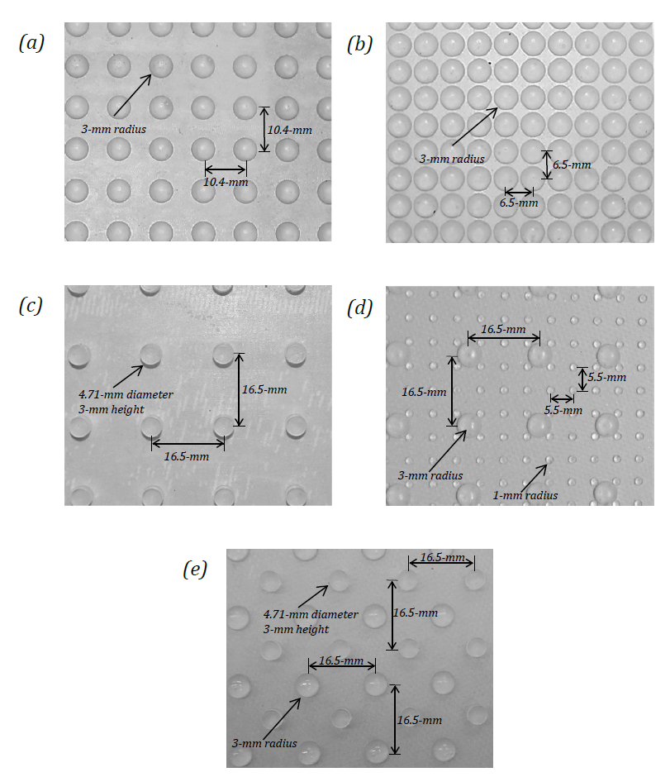
Figure 4 Roughness fetches of Meyers et al. (2015) included in the present data set. (a) sparse, ordered, 3-mm hemispheres (b) sparse, random, 3-mm hemispheres (c) sparse, ordered, 1-mm hemispheres
Figure 5 Geometry of newly designed roughness fetches. (a) intermediately-spaced, ordered, 3-mm hemispheres (b) densely-spaced, ordered, 3-mm hemispheres (c) sparse, ordered, 3-mm cylinders (d) multi-height roughness (e) multi-shape roughness

Summary of Data Set
The data from the experiments are summarised in following table. All data meet criteria for wall similarity and fully rough behaviour: $δ/k_{g}<50$ and $k_{g}^{+}>80$. The following sections will describe the data files in depth.
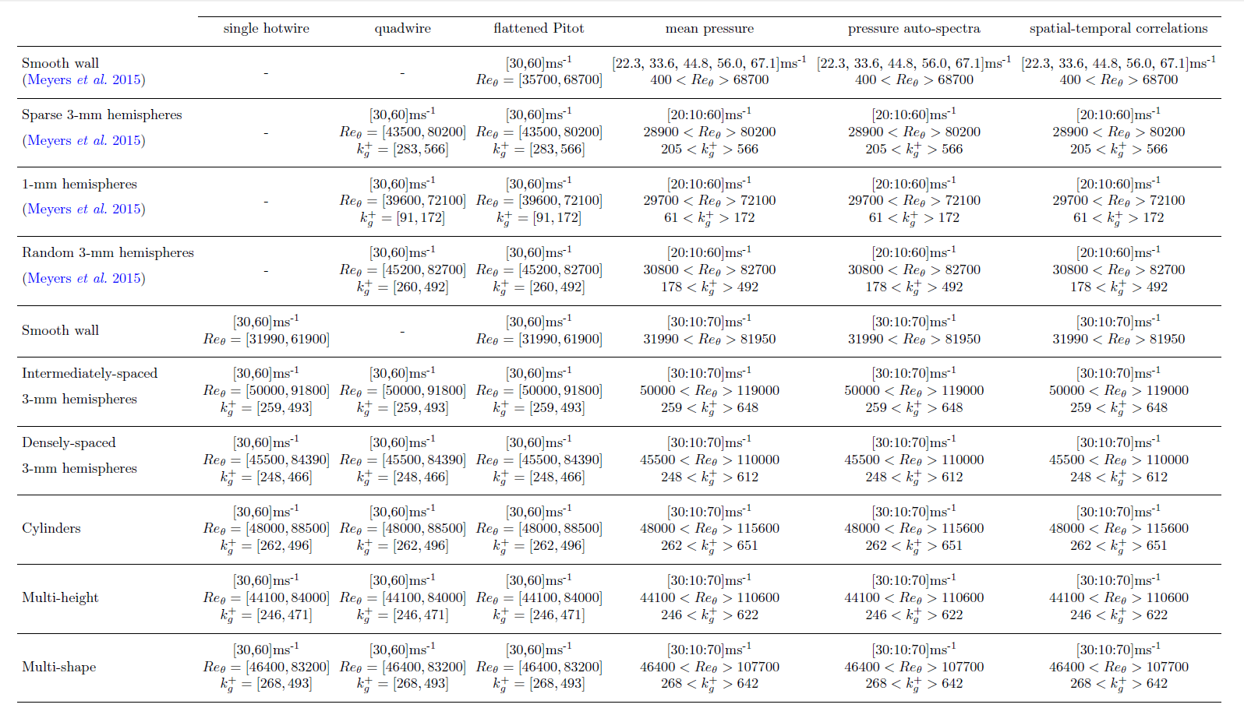

DATA: Turbulent Velocity Profiles
Velocity profile data are saved in the MATLAB strucutre named “Turbulent_Velocity”.
The MATLAB structure has the form:
Turbulent_Velocity.[type of probe].[rough surface].[free stream velocity]. [measured parameter]
Parameter | Description | Units
Uref | free-stream/edge velocity | m/s
nu | kinematic viscosity | m²/s
rho | density | kg/m³
x | streamwise probe location | m
z | spanwise probe location | m
y | wall-normal probe location | m
yoffset | wall-normal distance from wall to closest probe measurement | m
U | mean streamwise velocity | m/s
W | mean spanwise velocity | m/s
V | mean wall-normal velocity | m/s
u2 | Reynolds normal stress (streamwise) | m²/s²
v2 | Reynolds normal stress (spanwise) | m²/s²
w2 | Reynolds normal stress (wall-normal) | m²/s²
uv | Reynolds shear stress | m²/s²
vw | Reynolds shear stress | m²/s²
uw | Reynolds shear stress | m²/s²

DATA: Boundary Layer Parameters
Calculated boundary layer parameters are saved in the MATLAB strucutre named “Boundary_Layer_Parameters”.
The MATLAB structure has the form:
Boundary_Layer_Parameters..[type of probe].[rough surface]. [calculated parameter]
Parameter | Description | Units
Ue | free-stream/edge velocity | m/s
rho | density | kg/m³
nu | kinematic viscosity | m²/s
ksplus | sand-grain roughness Reynolds number | -
ks | effective sand-grain roughness | m
dUplus |  | -
deltaplus | boundary layer thickness Reynolds number | -
kgplus | geometric roughness height Reynolds number | -
Cf | skin friction coefficent | -
Tw | wall shear stress | N/m²
utau | friction velocity | m/s
Retheta | momentum thickness Reynolds number | -
theta | momentum thickness | m
deltastar | displacment thickness | m
delta | boundary layer thickness | m

Probe Locations for Turbulent Velocity Profiles & Boundary Layer Parameters
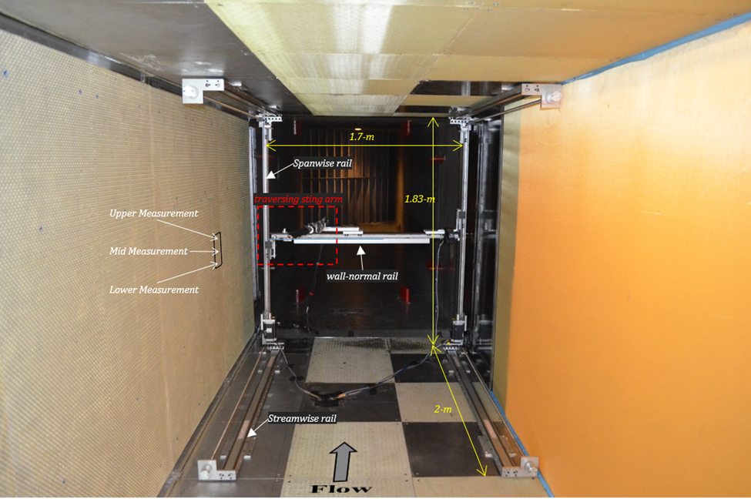

Figure 6: Upstream view looking downstream at the three-axis traverse system used to take the velocity measurements.
** Note the upper, lower, and mid-point measurement locations for flattened Pitot and single hotwires.
Cylinders
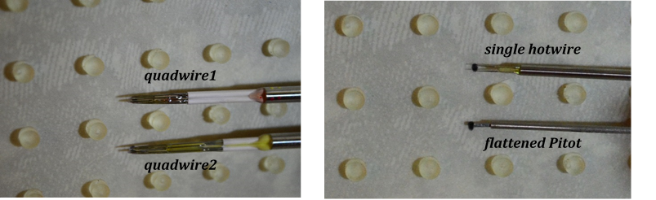
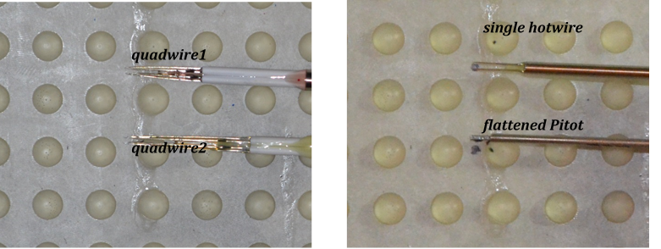
Intermediately-spaced Hemispheres
Densely-spaced Hemispheres
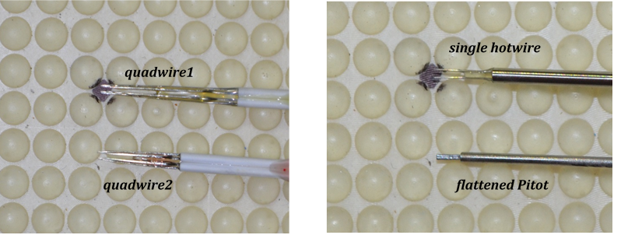
Multi-height Surface: Quadwire #1 and #2
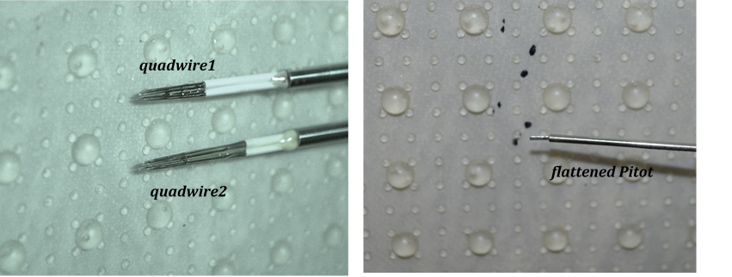
“MultiheightLoc1” == measurement downstream 1-mm hemispheres
“MultiheightLoc2” == measurement downstream 3-mm hemispheres
Multi-shape Surface: Quadwire #1 and #2
“MultishapeLoc1” == measurement downstream 3-mm hemispheres
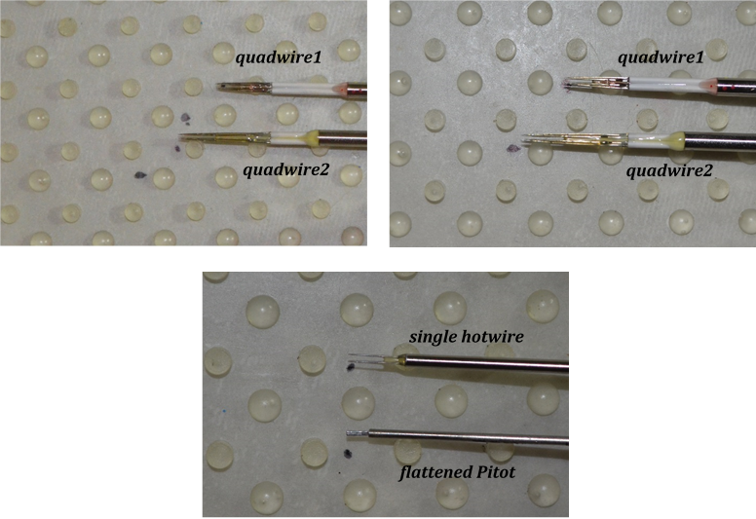
“MultishapeLoc2” == measurement downstream 3-mm cylinders
DATA: Pressure Spectra
Pressure spectra data are saved in the MATLAB strucutre named “Pressure_Autospectra”.
The MATLAB structure has the form:
Pressure_Autospectra. [rough surface].[free stream velocity]. [measured parameter]
Parameter | Description | Units
freq | frequency | Hz
SPLA | sound pressure level | dB
Ue | free stream/edge velocity | m/s

Probe Locations for Pressure Spectra

Multi-shape Surface
“Loc1” == microphone downstream a 3- mm cylinder
“Loc2” == microphone downstream a 3-mm hemisphere
“Loc3” == microphone 2-mm downstream a 3-mm cylinder
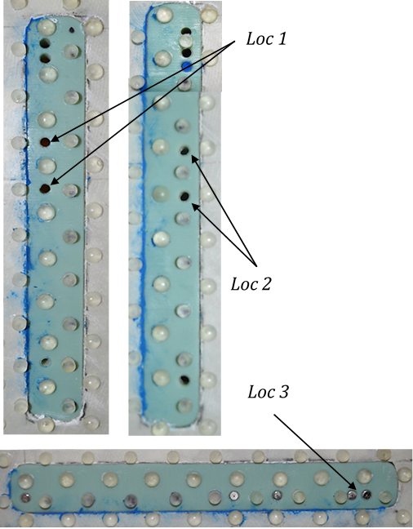
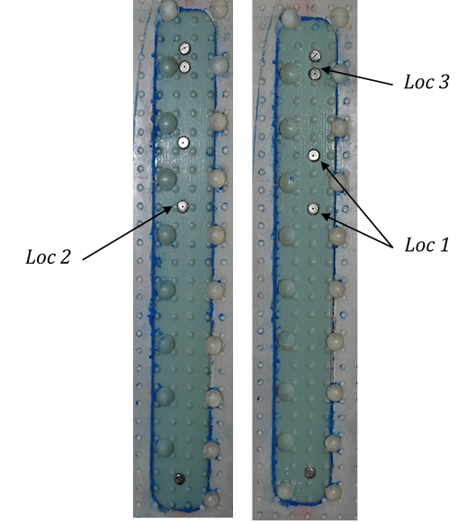
Multi-height Surface
“Loc1” == microphone ‘in-place’
of a 1-mm hemisphere
“Loc2” == microphone downstream
a 1-mm hemisphere
“Loc3” == microphone downstream
a 3-mm hemisphere

